ER-Diagram Hotel Management System

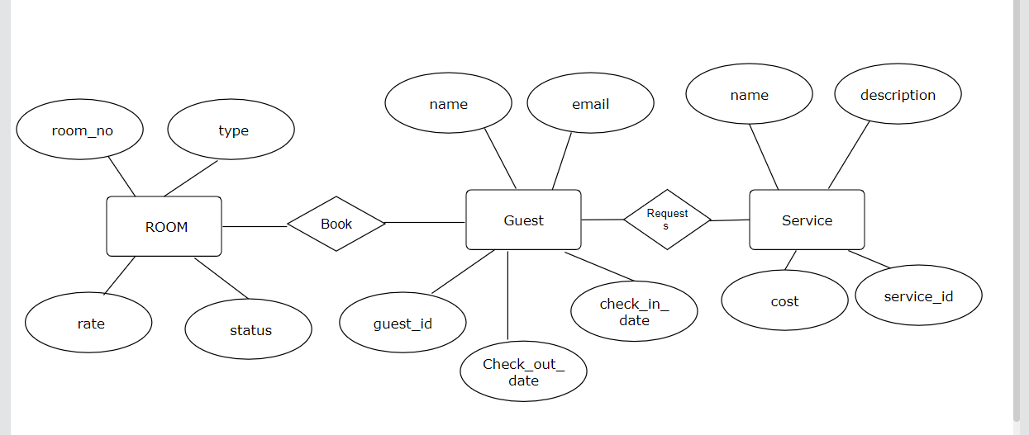

Note:-
Relationship between Entities:-
1. Room--------Guest (One to Many).
2.Guest---------Room(Many to one).
3.Guest--------Service(One to Many).
4.Service------Guest(Many to One).

